Assignment 3
  - Deadline: 29/04/2017 @ 23:59
[Total Mark for this Assignment is 4]

INTRODUCTION TO DATABASE
IT244

Instructions:
- This Assignment must be submitted on Blackboard via the allocated folder.
- Email submission will not be accepted.
- You are advised to make your work clear and well-presented, marks may be reduced for poor presentation.
- You MUST show all your work.
- Late submission will result in ZERO marks being awarded.
- Identical copy from students or other resources will result in ZERO marks for all involved students.

Student Details:
Name: ###  CRN: ### |  | ID: ###

Question One
2 Marks
Learning Outcome(s):
To understand the concept of the normalization process (1NF, 2NF, 3NF, and BCNF).
.

A. Consider the following relation R with all functional dependences F and normalize it into 2NF, 3NF, and BCNF.

R= {Patient_No,Patient_Name,App_No,Time,Doctor}
F= { Patient_No Patient_Name
Patient_No, App_No Time, Doctor
Time App_No }

B. Explain why the following relation R is in 3NF but not in BCNF.
R={a,b,c,d}
F= {a,b c,d
a,d b}

Question Two
2 Marks
Learning Outcome(s): To understand relation algebra expressions, To write relational algebra, and to analyze it

author(author_id, first_name, last_name)
author_pub(author_id, pub_id, author_position)
book(book_id, book_title, month, year, editor)
pub(pub_id, title, book_id)
- author_id in author_pub is a foreign key referencing author.
- pub_id in author_pub is a foreign key referencing pub
- book_id in pub is a foreign key referencing book
- editor in book is a foreign key referencing author(author_id)
- Primary keys are underlined

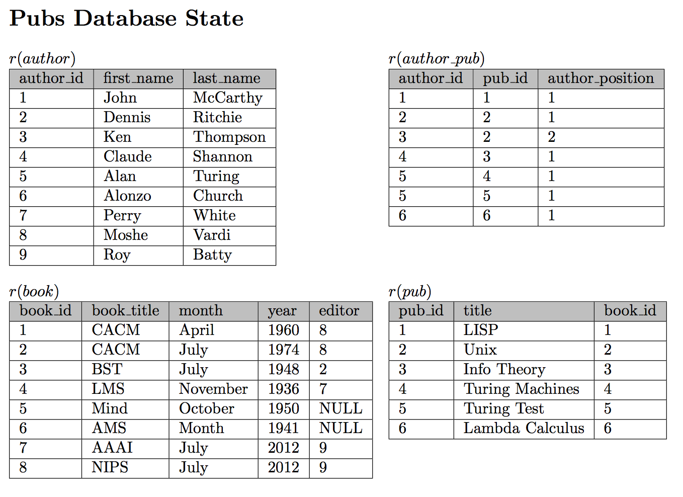

- How many tuples will be returned by the following relational algebra query?
Π _{book_title}(book)

- What question does the following expression answer?

Π _{author_id} (author) – Π _{editor}(book)

- Write a relational algebra expression that returns the names of all authors who are book editors.

- How many tuples are returned by the following relational algebra expression?
author ⨝ _{author_id=editor} book

